Button batteries – warning after two children die
21 Oct 2014
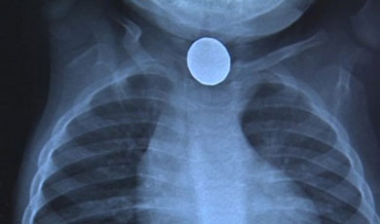
A stark warning has been issued by a paediatric consultant following the deaths of two children in Greater Manchester who had swallowed button batteries.
Dr Kate Parkins, a consultant at Central Manchester University Hospitals Trust added that, in the last 18 months, there have been a further five children who have suffered ‘life-changing’ injuries.
The lithium batteries are common in many homes, and are found in many items including smartphones, key cards, children’s games, watches, toys and even children’s books.

Severe internal bleeding
If swallowed, the batteries can cause severe internal bleeding which is very difficult to treat.
Quoted in an article on the BBC website, Dr Parkins explained:
"It's not what's inside the battery - the battery sets up an electrical current which causes a build-up of sodium hydroxide which is caustic soda.
"That causes a burn through the oesophagus, the feeding tube, and that can then burn through into major blood vessels and that's why the bleeding is then pretty much impossible to control and stop."
In one case, medics treating a three-year-old girl who died from severe blood loss, didn’t know that she had swallowed a battery.

Highlighting the risks
Because the batteries are small and round they are a huge risk to babies and toddlers. Even older children, who may mistake the batteries for sweets, are at risk. The oldest child treated in Manchester was six.
But because parents aren’t aware of the dangers posed by button batteries, they don’t think to put them out of children’s reach.
And it’s not just parents who need to be made aware - Dr Parkins reported that even some medical professionals aren’t aware of the damage the batteries can cause.

Help us spread the word
CAPT wants to draw attention to the danger posed by button batteries. We are urging practitioners to get the warning out to as many parents and carers as you can.
Please copy or print out this article, and use the BBC News story in any newsletters, websites or social media you use.
From Child Accident Prevention Trust website

